Ruling on limits means campaign contributions could soar

By Darla Cameron, Dan Keating and Laura Stanton, Published: April 2, 2014
Federal campaign finance laws limit how much an individual can give to specific candidates, committees and political action committees (PACs). Today, the U.S. Supreme Court overturned an additional limit on the aggregate amount that an individual could give to candidates, party committees and PACs. Without any aggregate limit, an individual can now give millions directly to candidates and parties.
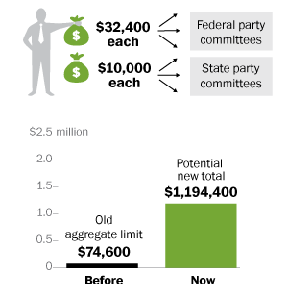

Candidates
Before, a single donor could contribute up to $5,200 to every House and Senate candidate up to a limit of $48,600.
Now, if a single donor gives $5,200 to every House and Senate candidates of one party in a 468-race election cycle, the total would be $2,433,600.

Party committees
Before, contributions to party committees were limited to $74,600 total.
Now, a single donor can give $32,400 to each of the three federal party committees each year and $10,000 to each of the party’s 50 state committees for up to $1,194,400 in donations in a two-year election cycle

Political action committees
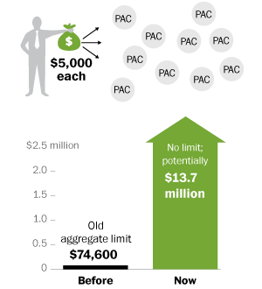
Before, contributions to PACs were limited to a total of $74,600 in increments of up to $5,000. There were 2,757 PACs in the 2012 election cycle.
Now, a single donor can give up to $5,000 to each PAC aligned with his or her political interest. If a donor spent $5,000 on every PAC in the 2012 election cycle that would equal $13.7 million.

